______________________________________________________________

UM-SJTU JOINT INSTITUTE

PHYSICS LABORATORY

(VP 241)

______________________________________________________________

LABORATORY REPORT

EXERCISE 4

POLARIZATION OF LIGHT

|  |  |  |
| --- | --- | --- |
| **Name: Weikai Zhou** | **ID: 518021911039** | **Group: 8** |
| Name: Yingtao Zou | ID: 518370910069 | Group: 8 |
|  |  |  |
| Date: 1 November 2019 |  |  |

1. **Introduction [1]**
   1. **Objectives**

* Try to understand some properties of light
* Study the polarization phenomenon
* Verify Malus’ law and understand the way half- and quarter-wave plates work in optical systems
* Investigate the generation and detection of elliptically and circularly polarized light
  1. **Theoretical background**

We can use electromagnetic waves to describe light, with the plane of oscillations of the electric field vector (as well as the magnetic field vector) perpendicular to the direction of light propagation. Therefore, light is an example of a transverse wave. Natural light means that the emitted light is a random mixture of waves with the electric field vector oscillating in all possible transverse directions. This is due to the randomness of the radiation mechanism. And we may also call the natural light unpolarized light. The distribution of the directions of the electric field vector, in the plane perpendicular to the direction of propagation, is uniform for the natural light. For polarized light, the distribution is not uniform. It is important for us to study the polarization of light in the development of wave optics. We can use them in a wide range of applications in numerous areas, such as optical measurement techniques, crystal structure research, and experimental stress analysis.

* + 1. **Polarization of light**

The electric field vector **E**, which in the context of electromagnetic waves corresponding to the visible part of the spectrum is sometimes referred to as the light vector, describes a time-dependent, propagating electric field. The light vector may have different directions along which its magnitude oscillates in the plane perpendicular to the propagation direction of a light. *Linearly polarized* light refers to the light whose light vector maintains a certain oscillation direction. And the polarization axis refers to the axis defining the direction (Figure 1).

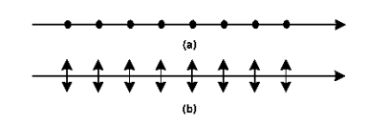The *circularly polarized* light refers to the light with the light vector direction rotating about the propagation direction and its endpoint traces a circle. If the vector traces an ellipse, the light said to be *elliptically polarized* (Figure 2).

Figure 1. (a) Linearly polarized light with the polarization axis perpendicular to the page

plane (b) Linearly polarized light with the polarization axis parallel to the page plane

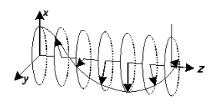Figure 2. Elliptically polarized light propagating in

the *z* direction. The light is polarized in the *xy* plane

The ordinary light source (natural light) emits unpolarized light. However, it can be regarded as a statistical equal-weight mixture of linearly polarized waves with equal amplitudes. Moreover, we may consider that it is a combination of a polarized and the natural (unpolarized) light, so it may be partially polarized. The direction corresponding to the maximum amplitude of the light vector of such partially polarized light is the oscillation direction of the polarized component.

* + 1. **Polarizer**

We often use a polaroid (also called a polarizer) to produce polarized light. It polarizes the light using the principle of dichroism, which states that a selective absorption mechanism tends to allow the light polarized in a certain direction (direction of the crystal alignment) to pass through the material, while the light polarized in all other directions is absorbed. Therefore, the polaroid can turn the incident natural light into linearly polarized.

A polarization device can not only change incident natural light to polarized light (it then acts as a polarizer), but may also be used to detect and analyze linearly polarized, natural, and partially polarized light (it is then called an analyzer).

* + 1. **Malus’ law**

Change of the light brightness is a visible effect in the light coming out of a polarization device

If we have two parallelly-arranged polarizers, the left one plays the role of a polarizer, the other one is an analyzer (Figure 3). Suppose the angle between their transmission directions (polarization axes) be *θ*. After the light is incident normally on the polarizer, it continues to the analyzer. The intensity of the linearly polarized light leaving the analyzer is

, (1)

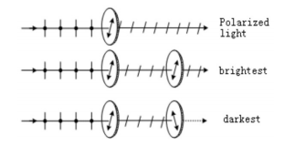where is the intensity of the linearly polarized light incident on the analyzer. Eq. (1) is called Malus’ law, which is named after Etienne-Louis Malus. And it is derived in 1809.

Figure 3. Change in the brightness of the light depends on

the mutual orientation of the polarizer and the analyzer

If polarized light incident on a single polarizer, the transmitted light intensity will change periodically when rotating the polarizer. If the incident light is partially or elliptically polarized, the minimum intensity will not be zero as there will be always some component of the light polarized in the transmission direction. If there is no change of the intensity, the incident light must be natural or circularly polarized. Therefore, we can use a polarizer to distinguish linearly polarized light from the natural and circularly polarized light.

* + 1. **Generation of elliptically and circularly polarized light. Half-wave and quarter-wave plates**

Suppose that linearly polarized light is incident normally on a crystal plate whose surface is parallel to its optical axis, and the angle between the polarizing axis and the optical axis of the plate is *α*. Then, we may find that the linearly polarized light is resolved into two waves which are an *e*-wave with the oscillation direction parallel to the optical axis of the plate (*extraordinary axis*) and an o-wave whose oscillation direction is perpendicular to the optical axis (*ordinary axis*) respectively. And they propagate in the same direction with different speeds. The resulting optical path difference over the thickness d of the plate is

and, we can calculate the phase difference as

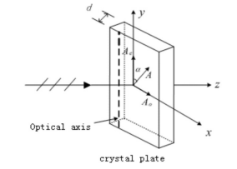where is the wavelength, is the refractive index for the extraordinary axis, and is the refractive index for the ordinary axis. in the positive crystal and in the negative crystal.

Figure 4. Linearly polarized light passing through a waveplate.

As shown in Figure 4, we can find the two components of the light vector when the light propagates through the crystal plate as

where , . We can get the following equation by eliminating time

We should note that this is the equation of an ellipse for *δ = ± π /* 2.

If we change the thickness of the plate, the optical path difference will also change accordingly. Below, we will discuss some interesting cases

* If , where *k* = 0,1 ,2, …, the phase difference , and Eq. (2) can be simplified as:

which is a linear equation. Therefore, the transmitted light is linearly polarized and the oscillation direction remains unchanged. We call the waveplate that satisfies this condition a *full-wave plate*. The light goes through a full-wave plate without changing its polarization state.

* If , where *k* = 0,1 ,2, …, the phase difference , and Eq. (2) can be simplified as:

The transmitted light is also linearly polarized and the polarization axis rotated by the angle of 2*α*. We call the waveplate that satisfies this condition a *half-wave plate*. If a polarized light passes through a half-wave plate, its polarization axis gets rotated by an angle 2*α*. In the case when *α* = , the polarization axis of the transmitted light is perpendicular to that of the incident light.

* If , where *k* = 0,1 ,2, …, the phase difference , and Eq. (2) can be simplified as:

We can find that the transmitted light is elliptically polarized. We call the waveplate that satisfies this condition a *quarter-wave plate*. This is an important optical element in many polarization experiments.

If , then we can get that and the transmitted light is circularly polarized. The polarization state after passing through a 1/4-wave plate will vary because the amplitudes of the *o*-wave and the *e*-wave are both functions of *α*, and it will depend on the angle:

* The transmitted light is linearly polarized with the polarization axis parallel to the optical axis of the 1/4–wave plate;
* The transmitted light is linearly polarized with the polarization axis perpendicular to the optical axis of the 1/4–wave plate;
* The transmitted light is circularly polarized;
* Other cases. The transmitted light is elliptically polarized.

1. **Apparatus [1]**
   1. **Experimental setup**

The experiment setup of this lab consists of a tungsten iodine lamp, a semiconductor laser, a UT51 digital universal meter, a silicon photo-cell, two polarizers, 1/2-wave and 1/4–wave plates and a lens with a glass sheet. We use an optical bench to help place them.

* 1. **Precision or uncertainty**

|  |  |  |  |
| --- | --- | --- | --- |
| Angle |  | Current |  |

Table 1. Precision or uncertainty of equipment

1. **Measurement procedure [1]**
   1. **Apparatus adjustment**
      1. 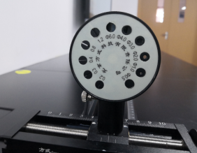We adjust the photo-cell by choosing the appropriate aperture. Form the figure below (Figure 5), we may find that there are different apertures on the photo-cell. In this experiment, we will only use the 6.0 aperture, which can preserve the incident light intensity. We should note that if we choose other aperture, the intensity of light may get reduced, resulting in a zero reading on the universal meter. Therefore, we should adjust the laser and the photo-cell so that the light can pass through the 6.0 aperture before proceeding to the nest steps.

Figure 5. Photo-cell

* + 1. Then, we place the lens and the glass sheet in front of it with the laser fixed at one of the ends of the bench. We should make sure that the light passes through the center of the lens.
    2. We adjust the distance between the lens and the laser to the focal length of the lens.
    3. We then move the glass sheet along the bench. If the size of the light spot on the glass varies significantly, we have to repeat Step 3.1.2..
    4. Finally, we can remove the glass sheet and set the digital universal meter in the appropriate mode and range.
  1. **Demonstration of Malus’ law**
     1. 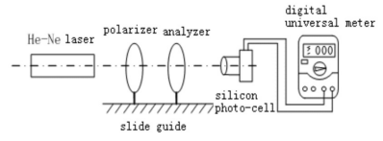First, we assemble the measurement setup as shown in Figure 6. We need to make sure that the laser ray passes through the polarizer to generate linearly polarized light before continuing to the analyzer and the silicon photo-cell.

Figure 6. Experimental setup for a demonstration of Malus’ law

* + 1. Then, we rotate the analyzer for 360 and observe a change in the light intensity to find the maximum electric current .
    2. Then, we rotate the analyzer until the electric current measured by the multimeter reaches its minimum. At this point, we consider that the polarizing axes of the polarizer and the analyzer are perpendicular to each other.
    3. Finally, we rotate the analyzer from 90 to 0 and record the magnitude of the current *I* every 5 . we can record the values in a table and plot the graph vs. . And we should perform linear fitting and compare the data with the theoretical result.
  1. **Linearly polarized light and the half-wave plate**
     1. 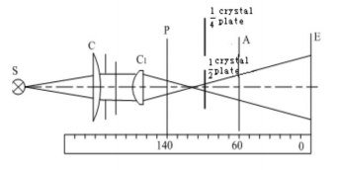First, we assemble the measurement setup as shown in Figure 7. *A* is the analyzer and *P* is the polarizer. Then, we should set the polarizing axes of *A* and *P* perpendicular to each other before placing the 1/2-wave plate in the apparatus; extinction of the light can be observed on screen.

Figure 7. Experimental setup for the 1/2-wave plate

* + 1. Then, we should rotate it to make the light extinction appear again and set this position as the initial position after inserting the 1/2-wave plate after inserting the 1/2-wave plate.
    2. If we rotate the 1/2-wave plate for *α* = 10 form the initial position, the light extinction will be broken. We can rotate *A* to make it appear it again. We should record the angle of rotation ∆*θ* in a table.
    3. Then, we should rotate the 1/2-wave plate for another 10 (now *α* = 20) and repeat Step 3.3.3.. We should keep increasing *α* each time by 10, and repeat this step. Finally, we should plot the graph ∆*θ* vs. *θ*.
  1. **Circularly and elliptically polarized light and the 1/4-wave plate**
     1. First, we should follow the Step 3.3.1.. and at this point, the angle *θ* = 90.
     2. After inserting the 1/4-wave plate, the light extinction will disappear. We should rotate it to make the light extinction appear again and set this position as the initial position. At this point, we regard *α* as 10. Then we should rotate the 1/4-wave plate and observe the change in the light intensity, which is reflected by the current *I*).
     3. Then we should rotate the analyzer for 10 each time and record the light intensity, which is indicated by the current *I*, until the analyzer rotates for a circle.
     4. We should rotate the 1/4-wave plate for 20 and repeat Step 3.4.3..
     5. We should rotate the 1/4-wave plate for 45 and repeat Step 3.4.3..
     6. We should rotate the 1/4-wave plate for 70. Then, we should rotate the analyzer and record its position and the magnitude of the current when the light intensity reaches a maximum.
     7. After that, we can use a computer to plot the relation between the rotation angle of the analyzer and the light amplitude in polar coordinates. We can normalize the amplitude by its maximum value. We then need to mark the position recorded in Step 3.4.6. and compare it with the data recorded in Step 3.4.4..

**Note**: the light intensity is found indirectly by measuring the electric current, and the intensity is proportional to the amplitude squared. The current indicates the intensity, not the amplitude.

* + 1. Finally, we compare the result of Step 3.4.5. with that for the circular polarization and plot a linear fit to the data when the angle is 45.

**Here are some important notifications:**

* We are not supposed to direct the laser beam into the eye.
* We are not supposed to touch the surface of the polarizers or the wave plates.

1. **Results**

(Detailed uncertainty calculation is in appendix.)

* 1. **Demonstration of Malus’ law**

As described in procedure 3.2., we can get the data in the following table (Table 2).

|  |  |  |  |
| --- | --- | --- | --- |
| Maximum electric current 0.9930.001[ | | | |
|  |  |  |  |
| 0 | 0.983 | 50 | 0.389 |
| 5 | 0.961 | 55 | 0.318 |
| 10 | 0.931 | 60 | 0.235 |
| 15 | 0.898 | 65 | 0.168 |
| 20 | 0.852 | 70 | 0.107 |
| 25 | 0.802 | 75 | 0.062 |
| 30 | 0.735 | 80 | 0.025 |
| 35 | 0.639 | 85 | 0.005 |
| 40 | 0.568 | 90 | 0.000 |
| 45 | 0.480 |  |  |

Table 2. Measurement data Malus’ law demonstration

Using the first data as an example, we can calculate that:

The whole table is listed below (Table 3):

|  |  |  |  |
| --- | --- | --- | --- |
|  | Uncertainty for | / | Uncertainty for / |
| 1.0 | 0.0 | 0.9899 | 0.0014 |
| 0.992 | 0.003 | 0.9678 | 0.0014 |
| 0.970 | 0.006 | 0.9376 | 0.0014 |
| 0.933 | 0.009 | 0.9043 | 0.0014 |
| 0.883 | 0.011 | 0.8580 | 0.0013 |
| 0.821 | 0.013 | 0.8077 | 0.0013 |
| 0.75 | 0.02 | 0.7402 | 0.0013 |
| 0.67 | 0.02 | 0.6435 | 0.0012 |
| 0.59 | 0.02 | 0.5720 | 0.0012 |
| 0.50 | 0.02 | 0.4834 | 0.0011 |
| 0.41 | 0.02 | 0.3917 | 0.0011 |
| 0.33 | 0.02 | 0.3202 | 0.0011 |
| 0.25 | 0.02 | 0.2367 | 0.0010 |
| 0.179 | 0.013 | 0.1692 | 0.0010 |
| 0.117 | 0.011 | 0.1078 | 0.0010 |
| 0.067 | 0.009 | 0.0624 | 0.0010 |
| 0.030 | 0.006 | 0.0252 | 0.0010 |
| 0.008 | 0.003 | 0.0050 | 0.0010 |
| 0.0 | 0.0 | 0.0000 | 0.0010 |

Table 3. Uncertainty data for Malus’ law demonstration

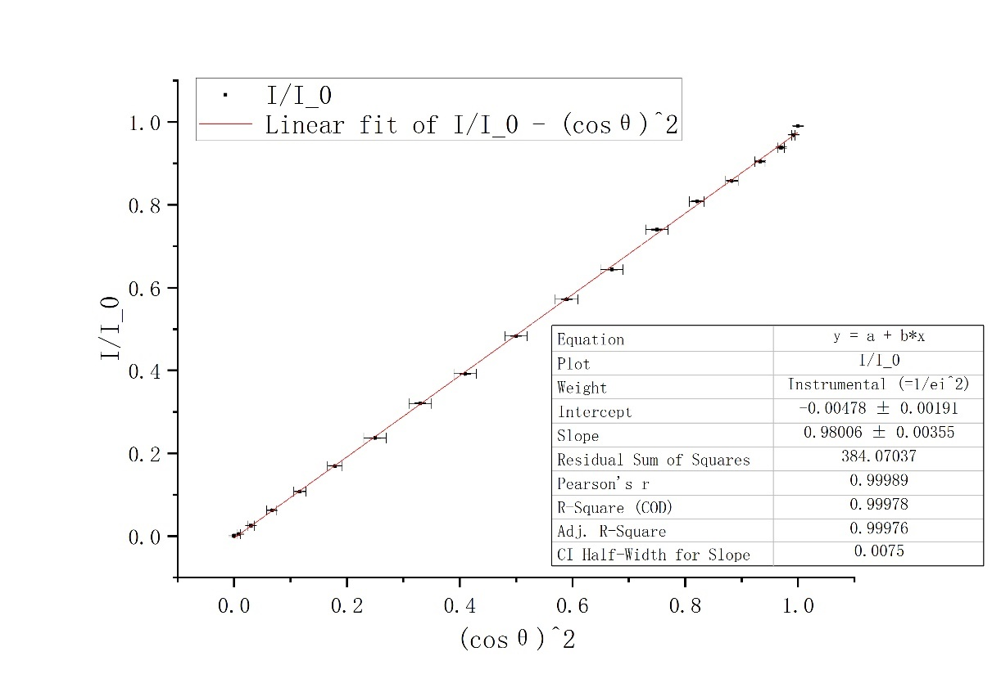Then, we can use Origin to apply linear fit to get Figure 8.

Figure 8. Linear fit of / vs.

From this figure, we can find that / = a + b, where intercept a = -0.00478, and slope b = 0.98006, and , Pearson’s r = 0.99989. Since CI Half-Width for Slope is 0.0075, we can get that

Moreover, since the current reflects the intensity of light, we can get that:

which is very close to 1. Therefore, we can consider our demonstration has proved Malus’ law.

* 1. **Linearly polarized light and the half-wave plate**

As described in procedure 3.3., we can get the data in the following table (Table 4).

|  |  |
| --- | --- |
| Rotation angle of the 1/2-wave plate [ | Rotation angle of the analyzer [ |
| Initial | 0 |
| 10 | 20 |
| 20 | 41 |
| 30 | 61 |
| 40 | 81 |
| 50 | 101 |
| 60 | 122 |
| 70 | 141 |
| 80 | 159 |
| 90 | 180 |

Table 4. Measurement data for the 1/2-wave plate

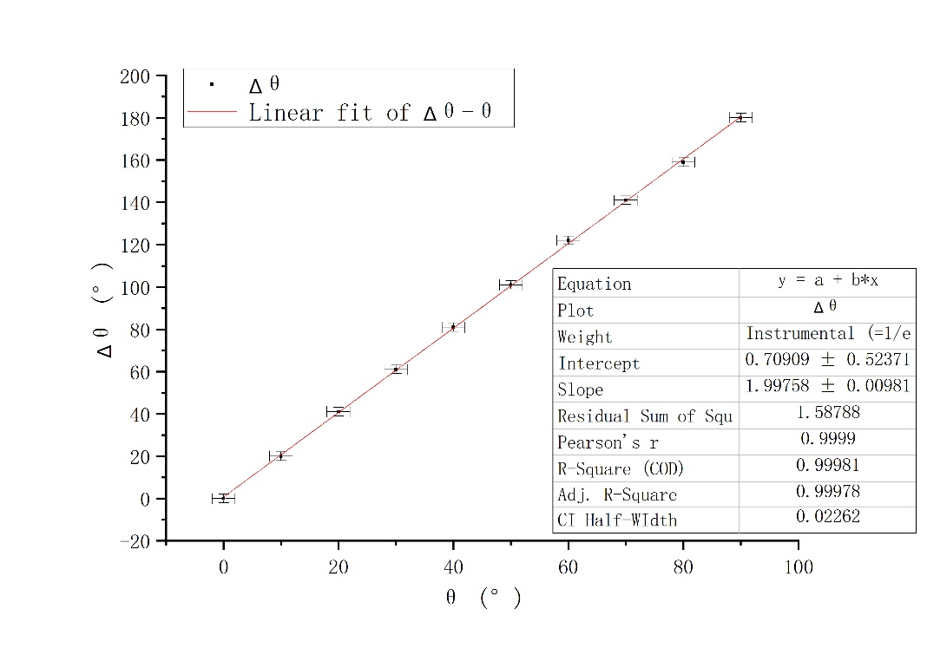Then, we can use Origin based on Table 3 to apply linear fit to get Figure 9.

Figure 9. Linear fit for vs.

From Figure 9, we can see that , where intercept a = 0.70909 and slope b = 1.99758and , Pearson’s r = 0.9999. Since CI Half-Width for Slope is 0.02262, we can get that

Based on the theory that when a polarized light passes through a half-wave plate, its polarization axis gets rotated by an angle 2*α*, the theoretical value for slope should be 2. And the experimental slope b is close to 2. Therefore, we have verified the theory.

Then, we may deduce that the light extinction be observed 4 times when the 1/2-wave plate rotates for 360. This is because of the theory that if a polarized light passes through a half-wave plate, its polarization axis gets rotated by an angle 2*α*. Therefore, if we rotate the 1/2-wave plate for 360, the polarized light will rotate 720, during which there are four cases when the axis of the polarized light is perpendicular to the polarizing axes of analyzer. They are the cases that the 1/2-wave plate rotates for 90, 180, 270 and 360 respectively.

Similarly, the light extinction be observed 2 times when the analyzer rotates for 360. Since it rotates the analyzer for 360, the relative angle rotated is also 360. Therefore, there are only 2 times, which are the cases that the analyzer rotates for 180 and 360 respectively.

And if a polarized light passes through a half-wave plate, its polarization axis gets rotated by an angle 2*α*

* 1. **Circularly and elliptically polarized light and the 1/4-wave plate**
     1. **1/4-wave plate with rotation angle 0**

As described in procedure 3.4., we can get the data in the following table (Table 5).

|  |  |  |  |
| --- | --- | --- | --- |
| Rotation angle of 1/4-wave plate: 0 | | | |
| Maximum electric current 0.6380.001[ | | | |
|  |  |  |  |
| 0 | 0.621 | 180 | 0.638 |
| 10 | 0.612 | 190 | 0.612 |
| 20 | 0.575 | 200 | 0.556 |
| 30 | 0.492 | 210 | 0.469 |
| 40 | 0.388 | 220 | 0.372 |
| 50 | 0.270 | 230 | 0.249 |
| 60 | 0.158 | 240 | 0.150 |
| 70 | 0.072 | 250 | 0.067 |
| 80 | 0.022 | 260 | 0.017 |
| 90 | 0.001 | 270 | 0.001 |
| 100 | 0.020 | 280 | 0.022 |
| 110 | 0.074 | 290 | 0.082 |
| 120 | 0.156 | 300 | 0.167 |
| 130 | 0.258 | 310 | 0.276 |
| 140 | 0.376 | 320 | 0.380 |
| 150 | 0.470 | 330 | 0.484 |
| 160 | 0.548 | 340 | 0.566 |
| 170 | 0.606 | 350 | 0.605 |

Table 5. Measurement data for the 1/4-wave plate (rotation angle 0)

Using the first data as an example, we can calculate that:

The whole table is listed below (Table 6):

|  |  |  |  |
| --- | --- | --- | --- |
| [] | Uncertainty of [] |  | Uncertainty of |
| 0 | 2 | 0.9866 | 0.0011 |
| 10 | 2 | 0.9794 | 0.0011 |
| 20 | 2 | 0.9493 | 0.0011 |
| 30 | 2 | 0.8782 | 0.0011 |
| 40 | 2 | 0.7798 | 0.0012 |
| 50 | 2 | 0.6505 | 0.0013 |
| 60 | 2 | 0.498 | 0.002 |
| 70 | 2 | 0.336 | 0.002 |
| 80 | 2 | 0.186 | 0.004 |
| 90 | 2 | 0.04 | 0.02 |
| 100 | 2 | 0.177 | 0.004 |
| 110 | 2 | 0.341 | 0.002 |
| 120 | 2 | 0.494 | 0.002 |
| 130 | 2 | 0.6359 | 0.0013 |
| 140 | 2 | 0.7677 | 0.0012 |
| 150 | 2 | 0.8583 | 0.0011 |
| 160 | 2 | 0.9268 | 0.0011 |
| 170 | 2 | 0.9746 | 0.0011 |
| 180 | 2 | 1.0000 | 0.0011 |
| 190 | 2 | 0.9794 | 0.0011 |
| 200 | 2 | 0.9335 | 0.0011 |
| 210 | 2 | 0.8574 | 0.0011 |
| 220 | 2 | 0.7636 | 0.0012 |
| 230 | 2 | 0.6247 | 0.0013 |
| 240 | 2 | 0.4849 | 0.0017 |
| 250 | 2 | 0.324 | 0.002 |
| 260 | 2 | 0.163 | 0.005 |
| 270 | 2 | 0.04 | 0.02 |
| 280 | 2 | 0.186 | 0.004 |
| 290 | 2 | 0.359 | 0.002 |
| 300 | 2 | 0.512 | 0.002 |
| 310 | 2 | 0.6577 | 0.0013 |
| 320 | 2 | 0.7718 | 0.0012 |
| 330 | 2 | 0.8710 | 0.0011 |
| 340 | 2 | 0.9419 | 0.0011 |
| 350 | 2 | 0.9738 | 0.0011 |

Table 6. Calculated data for the 1/4-wave plate (rotation angle 0)

Based on Table 6, we can use Origin to get the graph that

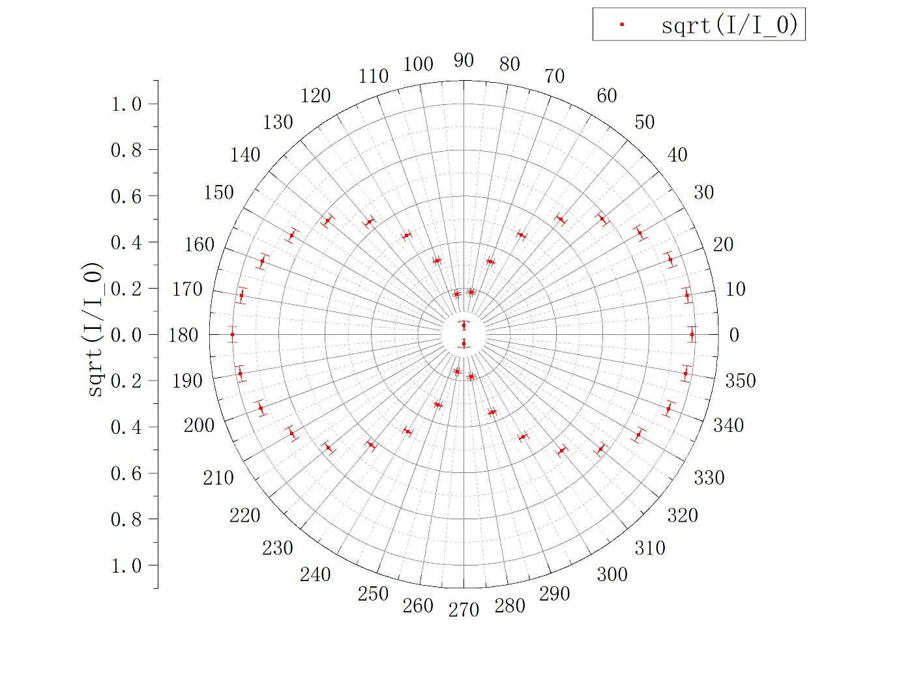Figure 10. Relative relation between and the light amplitude for 1/4-wave plate with 0

Based on the theory that if *α* = 0, the transmitted light is linearly polarized with the polarization axis parallel to the optical axis of the 1/4–wave plate. From Figure 10, we can find that the amplitude is related to the rotated angle because the amplitude first decreases, then increases and decreases and finally increases with the growth of . And there are the points where the amplitude equals zero. And this corresponds to the characteristic of the linearly polarized light.

* + 1. **1/4-wave plate with rotation angle 20**

As described in procedure 3.4., we can get the data in the following table (Table 7).

|  |  |  |  |
| --- | --- | --- | --- |
| Rotation angle of 1/4-wave plate: 20 | | | |
| Maximum electric current 0.5770.001[ | | | |
|  |  |  |  |
| 0 | 0.542 | 180 | 0.577 |
| 10 | 0.528 | 190 | 0.566 |
| 20 | 0.493 | 200 | 0.531 |
| 30 | 0.436 | 210 | 0.468 |
| 40 | 0.357 | 220 | 0.366 |
| 50 | 0.273 | 230 | 0.296 |
| 60 | 0.200 | 240 | 0.206 |
| 70 | 0.141 | 250 | 0.145 |
| 80 | 0.094 | 260 | 0.101 |
| 90 | 0.080 | 270 | 0.086 |
| 100 | 0.094 | 280 | 0.095 |
| 110 | 0.137 | 290 | 0.135 |
| 120 | 0.203 | 300 | 0.184 |
| 130 | 0.304 | 310 | 0.252 |
| 140 | 0.377 | 320 | 0.334 |
| 150 | 0.455 | 330 | 0.404 |
| 160 | 0.532 | 340 | 0.461 |
| 170 | 0.562 | 350 | 0.504 |

Table 7. Measurement data for the 1/4-wave plate (rotation angle 20)

Using the first data as an example, we can calculate that:

The whole table is listed below (Table 8):

|  |  |  |  |
| --- | --- | --- | --- |
| [] | Uncertainty of [] |  | Uncertainty of |
| 0 | 2 | 0.9692 | 0.0012 |
| 10 | 2 | 0.9566 | 0.0012 |
| 20 | 2 | 0.9243 | 0.0012 |
| 30 | 2 | 0.8693 | 0.0012 |
| 40 | 2 | 0.7866 | 0.0013 |
| 50 | 2 | 0.6878 | 0.0014 |
| 60 | 2 | 0.589 | 0.002 |
| 70 | 2 | 0.494 | 0.002 |
| 80 | 2 | 0.404 | 0.002 |
| 90 | 2 | 0.372 | 0.002 |
| 100 | 2 | 0.404 | 0.002 |
| 110 | 2 | 0.487 | 0.002 |
| 120 | 2 | 0.593 | 0.002 |
| 130 | 2 | 0.7259 | 0.0013 |
| 140 | 2 | 0.8083 | 0.0013 |
| 150 | 2 | 0.8880 | 0.0012 |
| 160 | 2 | 0.9602 | 0.0012 |
| 170 | 2 | 0.9869 | 0.0012 |
| 180 | 2 | 1.0000 | 0.0012 |
| 190 | 2 | 0.9904 | 0.0012 |
| 200 | 2 | 0.9593 | 0.0012 |
| 210 | 2 | 0.9006 | 0.0012 |
| 220 | 2 | 0.7964 | 0.0013 |
| 230 | 2 | 0.7162 | 0.0014 |
| 240 | 2 | 0.598 | 0.002 |
| 250 | 2 | 0.501 | 0.002 |
| 260 | 2 | 0.418 | 0.002 |
| 270 | 2 | 0.386 | 0.002 |
| 280 | 2 | 0.406 | 0.002 |
| 290 | 2 | 0.484 | 0.002 |
| 300 | 2 | 0.565 | 0.002 |
| 310 | 2 | 0.6609 | 0.0014 |
| 320 | 2 | 0.7608 | 0.0013 |
| 330 | 2 | 0.8368 | 0.0013 |
| 340 | 2 | 0.8938 | 0.0012 |
| 350 | 2 | 0.9346 | 0.0012 |

Table 8. Calculated data for the 1/4-wave plate (rotation angle 20)

Based on Table 8, we can use Origin to get the graph (Figure 11) that

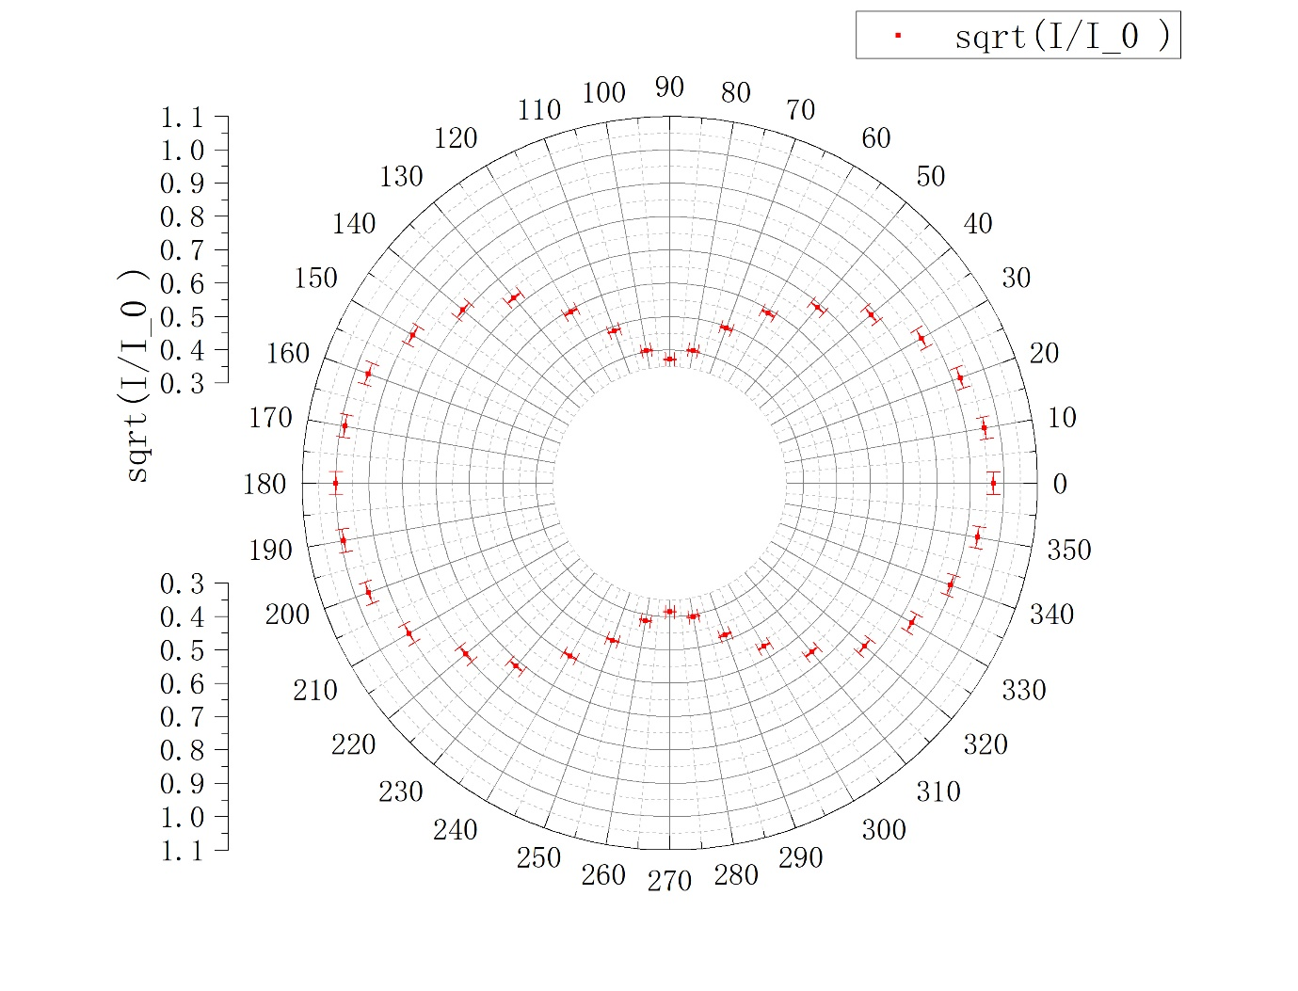

Figure 11. Relative relation between and the light amplitude for 1/4-wave plate with 20

Based on the theory that if *α* 0, *π*/2 or *π*/4, the transmitted light is elliptically polarized. And we can find that for almost every angle, the amplitude does not equal to zero but the amplitudes are not almost the same for all the angle. therefore, it corresponds to the characteristic of the elliptically polarized light.

* + 1. **1/4-wave plate with rotation angle 45**

As described in procedure 3.4., we can get the data in the following table (Table 9).

|  |  |  |  |
| --- | --- | --- | --- |
| Rotation angle of 1/4-wave plate: 45 | | | |
| Maximum electric current 0.3680.001[ | | | |
|  |  |  |  |
| 0 | 0.324 | 180 | 0.322 |
| 10 | 0.317 | 190 | 0.319 |
| 20 | 0.314 | 200 | 0.320 |
| 30 | 0.317 | 210 | 0.318 |
| 40 | 0.322 | 220 | 0.321 |
| 50 | 0.327 | 230 | 0.326 |
| 60 | 0.335 | 240 | 0.335 |
| 70 | 0.353 | 250 | 0.345 |
| 80 | 0.343 | 260 | 0.352 |
| 90 | 0.348 | 270 | 0.360 |
| 100 | 0.348 | 280 | 0.366 |
| 110 | 0.350 | 290 | 0.366 |
| 120 | 0.346 | 300 | 0.368 |
| 130 | 0.364 | 310 | 0.363 |
| 140 | 0.358 | 320 | 0.356 |
| 150 | 0.350 | 330 | 0.349 |
| 160 | 0.342 | 340 | 0.337 |
| 170 | 0.328 | 350 | 0.330 |

Table 9. Measurement data for the 1/4-wave plate (rotation angle 45)

Using the first data as an example, we can calculate that:

The whole table is listed below (Table 10):

|  |  |  |  |
| --- | --- | --- | --- |
| [] | Uncertainty of [] |  | Uncertainty of |
| 0 | 2 | 0.938 | 0.002 |
| 10 | 2 | 0.928 | 0.002 |
| 20 | 2 | 0.924 | 0.002 |
| 30 | 2 | 0.928 | 0.002 |
| 40 | 2 | 0.935 | 0.002 |
| 50 | 2 | 0.943 | 0.002 |
| 60 | 2 | 0.954 | 0.002 |
| 70 | 2 | 0.979 | 0.002 |
| 80 | 2 | 0.965 | 0.002 |
| 90 | 2 | 0.972 | 0.002 |
| 100 | 2 | 0.972 | 0.002 |
| 110 | 2 | 0.975 | 0.002 |
| 120 | 2 | 0.970 | 0.002 |
| 130 | 2 | 0.995 | 0.002 |
| 140 | 2 | 0.986 | 0.002 |
| 150 | 2 | 0.975 | 0.002 |
| 160 | 2 | 0.964 | 0.002 |
| 170 | 2 | 0.944 | 0.002 |
| 180 | 2 | 0.935 | 0.002 |
| 190 | 2 | 0.931 | 0.002 |
| 200 | 2 | 0.933 | 0.002 |
| 210 | 2 | 0.930 | 0.002 |
| 220 | 2 | 0.934 | 0.002 |
| 230 | 2 | 0.941 | 0.002 |
| 240 | 2 | 0.954 | 0.002 |
| 250 | 2 | 0.968 | 0.002 |
| 260 | 2 | 0.978 | 0.002 |
| 270 | 2 | 0.989 | 0.002 |
| 280 | 2 | 0.997 | 0.002 |
| 290 | 2 | 0.997 | 0.002 |
| 300 | 2 | 1.000 | 0.002 |
| 310 | 2 | 0.993 | 0.002 |
| 320 | 2 | 0.984 | 0.002 |
| 330 | 2 | 0.974 | 0.002 |
| 340 | 2 | 0.957 | 0.002 |
| 350 | 2 | 0.947 | 0.002 |

Table 10. Calculated data for the 1/4-wave plate (rotation angle 45)

Based on Table 10, we can use Origin to get the graph (Figure 12) that

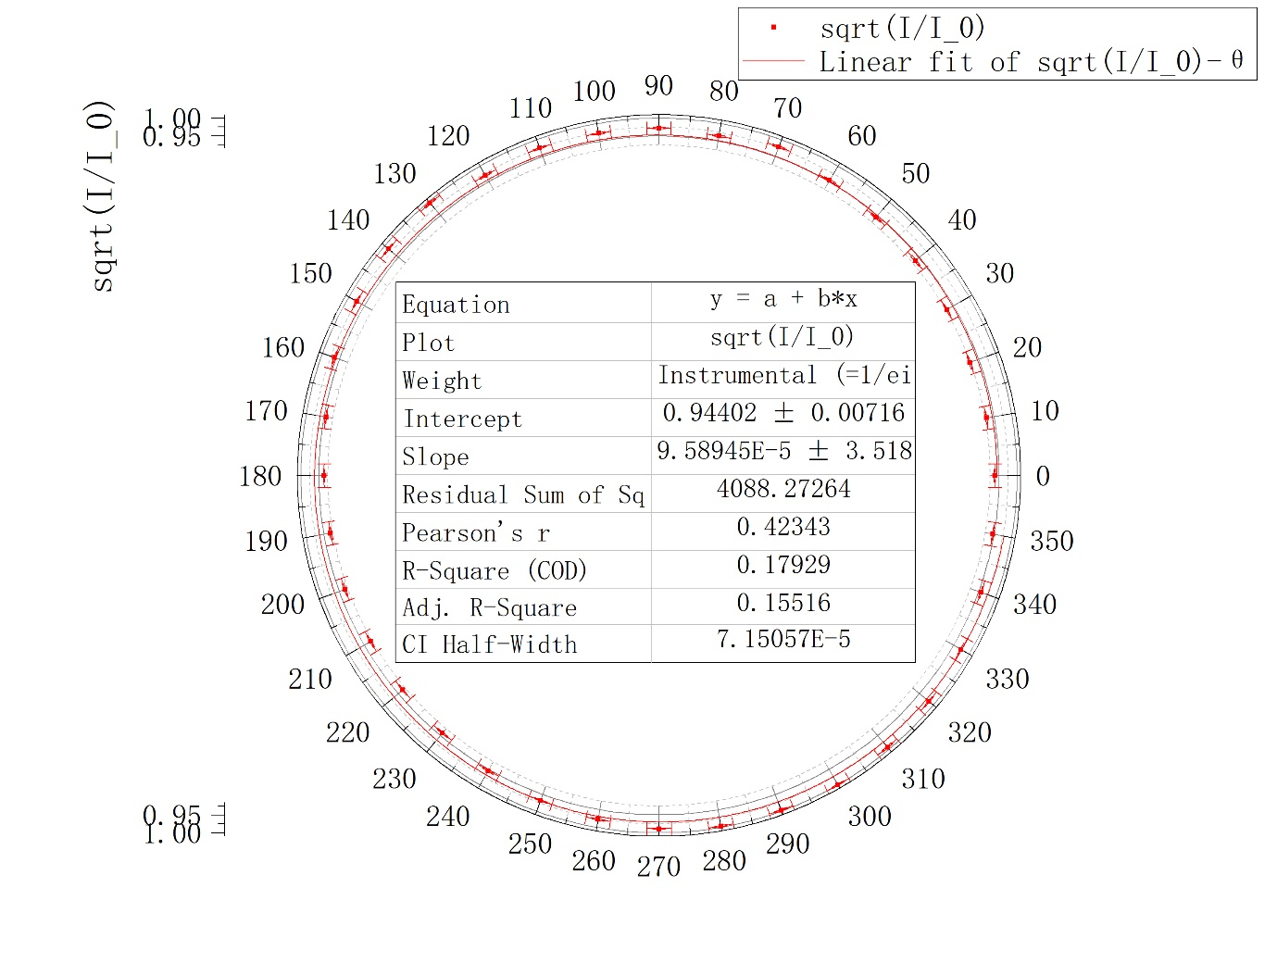

Figure 12. Relative relation between and the light amplitude for 1/4-wave plate with 20

After applying linear fit, we find that a = 0.94402, and b = 9.58945 . However, and Pearson’s r = 0.42343. Therefore, we cannot think that amplitude and are linearly dependent. Actually, we find that, the amplitude keeps stable for almost every . Based on the theory that if *α = π*/4, the transmitted light is circularly polarized. And the findings of the experiment correspond to the characteristic of the circularly polarized light.

* + 1. **1/4-wave plate with rotation angle 70**

As described in procedure 3.4., we can get the data in the following table (Table 11).

|  |  |
| --- | --- |
| Rotation angle of the 1/4-wave plate: 70 | |
|  | 140 |
|  | 0.609 |

Table 11. Measurement data for the 1/4-wave plate (rotation angle 70)

The corresponding point is circled at Figure 11. Theoretically, the maximum current when the rotation angle is 70 should equals to that of the rotation angle is 20. Moreover, the corresponding angle in Figure 11 should have about a 50 difference with 140. However, in the experimental data, we find that the maximum current when the rotation angle is 70 is larger than that of the rotation angle is 20, and the difference of angle is about 40 rather than 50. After considering the operations we have during the lab, we may think that it is because of the fixation of the 1/4-wave plate. Our 1/4-wave plate cannot be fixed to the pathway firmly. Then, if we rotate the 1/4-wave plate, it will change its position. So, this may contribute to the deviation of the result. Besides, the use of flashlight and manual rotation during the lab can also influence the final result.

1. **Conclusion [1]**

In this lab, we first demonstrate the Malus’ law. We apply linear fit for / vs. and find that

Theoretically, this value should equal to 1. The reasons for the deviation may be that when we rotate the polarizer or analyzer may not be exactly 10. Moreover, there may also be some problems with the apparatus adjustment.

Then, we study linearly polarized light and the half-wave plate. We apply linear fit for ∆𝜃 vs. 𝜃. Theoretically, if a polarized light passes through a half-wave plate, its polarization axis gets rotated by an angle 2*α*. Therefore, the theoretical coefficient for *α* is supposed to be 2. And then, in our experiment, we get that the coefficient of *α* is 2.00 ± 0.02. And this is very close to the theoretical value. We may consider this part as highly perfect. And we considered that the light extinction be observed 4 times when the 1/2-wave plate rotates for 360°, and the light extinction be observed 2 times when the analyzer rotates for 360°. The analysis is in the result part.

Finally, we study circularly and elliptically polarized light and the 1/4-wave plate. We first study 1/4-wave plate with rotation angle 0°, which should generate linearly polarized light with the polarization axis parallel to the optical axis of the 1/4–wave plate theoretically. According to the experimental data, we verified this theory. Then, we study 1/4-wave plate with rotation angle 20°, which should generate elliptically polarized light. Also, according to the experimental data, we verified this theory. Then, we study 1/4-wave plate with rotation angle 45°, which should generate circularly polarized light. And the findings of the experiment correspond to the characteristic of the circularly polarized light. Then, we study 1/4-wave plate with rotation angle 70°. This experiment should have a special relation with that of rotation angle 20°. However, in the result part, we find the relation is not close to the theoretical value. And we contribute it the fixation of instrument, the use of flashlight and manual work during lab.

Therefore, when it comes to the improvements, we hope that we can change the instrument for better ones that have firm fixation and can replace manual work as much as possible. Moreover, we should further limit the use of flashlight during lab.

Overall, during the lab, we have understood some properties of light, studied the polarization phenomenon, verified Malus’ law, understood the way half- and quarter-wave plates work in optical systems and investigated the generation and detection of elliptically and circularly polarized light. Therefore, it is a successful experiment.

1. **References**

[1] Exercise 3 - lab manual [rev 5.2], UM-JI SJTU. Edited by Qin Tian, Zheng Huan, Li Yingyu, Li Tiantian, Mateusz Krzyzosiak.

[2] Uncertainty analysis handbook, UM-JI SJTU.

1. **Uncertainty analysis [2]**

**A.1. Uncertainty for demonstration of Malus’ law**

Since and are measured directly, they only have type-B uncertainty, therefore:

Then, for /, we use the first data as an example and calculate below:

Since is measured directly, it only has type-B uncertainty, therefore:

Then, for , we use the first data as an example and calculate below:

The whole uncertainty is listed below (Table 12):

|  |  |  |  |
| --- | --- | --- | --- |
|  | Uncertainty for | / | Uncertainty for / |
| 1.0 | 0.0 | 0.9899 | 0.0014 |
| 0.992 | 0.003 | 0.9678 | 0.0014 |
| 0.970 | 0.006 | 0.9376 | 0.0014 |
| 0.933 | 0.009 | 0.9043 | 0.0014 |
| 0.883 | 0.011 | 0.8580 | 0.0013 |
| 0.821 | 0.013 | 0.8077 | 0.0013 |
| 0.75 | 0.02 | 0.7402 | 0.0013 |
| 0.67 | 0.02 | 0.6435 | 0.0012 |
| 0.59 | 0.02 | 0.5720 | 0.0012 |
| 0.50 | 0.02 | 0.4834 | 0.0011 |
| 0.41 | 0.02 | 0.3917 | 0.0011 |
| 0.33 | 0.02 | 0.3202 | 0.0011 |
| 0.25 | 0.02 | 0.2367 | 0.0010 |
| 0.179 | 0.013 | 0.1692 | 0.0010 |
| 0.117 | 0.011 | 0.1078 | 0.0010 |
| 0.067 | 0.009 | 0.0624 | 0.0010 |
| 0.030 | 0.006 | 0.0252 | 0.0010 |
| 0.008 | 0.003 | 0.0050 | 0.0010 |
| 0.0 | 0.0 | 0.0000 | 0.0010 |

Table 12. Uncertainty for demonstration of Malus’ law

**A.2. Uncertainty for Linearly polarized light and the half-wave plate**

Since and are measured directly, they only have type-B uncertainty, therefore:

**A.3. Uncertainty for circularly and elliptically polarized light and the 1/4-wave plate**

**A.3.1. 1/4-wave plate with rotation angle 0**

Since , and are measured directly, they only have type-B uncertainty, therefore:

Then, for , we use the first data as an example and calculate below:

The whole uncertainty is listed below (Table 13):

|  |  |  |  |
| --- | --- | --- | --- |
| [] | Uncertainty of [] |  | Uncertainty of |
| 0 | 2 | 0.9866 | 0.0011 |
| 10 | 2 | 0.9794 | 0.0011 |
| 20 | 2 | 0.9493 | 0.0011 |
| 30 | 2 | 0.8782 | 0.0011 |
| 40 | 2 | 0.7798 | 0.0012 |
| 50 | 2 | 0.6505 | 0.0013 |
| 60 | 2 | 0.498 | 0.002 |
| 70 | 2 | 0.336 | 0.002 |
| 80 | 2 | 0.186 | 0.004 |
| 90 | 2 | 0.04 | 0.02 |
| 100 | 2 | 0.177 | 0.004 |
| 110 | 2 | 0.341 | 0.002 |
| 120 | 2 | 0.494 | 0.002 |
| 130 | 2 | 0.6359 | 0.0013 |
| 140 | 2 | 0.7677 | 0.0012 |
| 150 | 2 | 0.8583 | 0.0011 |
| 160 | 2 | 0.9268 | 0.0011 |
| 170 | 2 | 0.9746 | 0.0011 |
| 180 | 2 | 1.0000 | 0.0011 |
| 190 | 2 | 0.9794 | 0.0011 |
| 200 | 2 | 0.9335 | 0.0011 |
| 210 | 2 | 0.8574 | 0.0011 |
| 220 | 2 | 0.7636 | 0.0012 |
| 230 | 2 | 0.6247 | 0.0013 |
| 240 | 2 | 0.4849 | 0.0017 |
| 250 | 2 | 0.324 | 0.002 |
| 260 | 2 | 0.163 | 0.005 |
| 270 | 2 | 0.04 | 0.02 |
| 280 | 2 | 0.186 | 0.004 |
| 290 | 2 | 0.359 | 0.002 |
| 300 | 2 | 0.512 | 0.002 |
| 310 | 2 | 0.6577 | 0.0013 |
| 320 | 2 | 0.7718 | 0.0012 |
| 330 | 2 | 0.8710 | 0.0011 |
| 340 | 2 | 0.9419 | 0.0011 |
| 350 | 2 | 0.9738 | 0.0011 |

Table 13. Uncertainty for 1/4-wave plate with rotation angle 0

**A.3.2. 1/4-wave plate with rotation angle 20**

Since , and are measured directly, they only have type-B uncertainty, therefore:

Then, for , we use the first data as an example and calculate below:

The whole uncertainty is listed below (Table 14):

|  |  |  |  |
| --- | --- | --- | --- |
| [] | Uncertainty of [] |  | Uncertainty of |
| 0 | 2 | 0.9692 | 0.0012 |
| 10 | 2 | 0.9566 | 0.0012 |
| 20 | 2 | 0.9243 | 0.0012 |
| 30 | 2 | 0.8693 | 0.0012 |
| 40 | 2 | 0.7866 | 0.0013 |
| 50 | 2 | 0.6878 | 0.0014 |
| 60 | 2 | 0.589 | 0.002 |
| 70 | 2 | 0.494 | 0.002 |
| 80 | 2 | 0.404 | 0.002 |
| 90 | 2 | 0.372 | 0.002 |
| 100 | 2 | 0.404 | 0.002 |
| 110 | 2 | 0.487 | 0.002 |
| 120 | 2 | 0.593 | 0.002 |
| 130 | 2 | 0.7259 | 0.0013 |
| 140 | 2 | 0.8083 | 0.0013 |
| 150 | 2 | 0.8880 | 0.0012 |
| 160 | 2 | 0.9602 | 0.0012 |
| 170 | 2 | 0.9869 | 0.0012 |
| 180 | 2 | 1.0000 | 0.0012 |
| 190 | 2 | 0.9904 | 0.0012 |
| 200 | 2 | 0.9593 | 0.0012 |
| 210 | 2 | 0.9006 | 0.0012 |
| 220 | 2 | 0.7964 | 0.0013 |
| 230 | 2 | 0.7162 | 0.0014 |
| 240 | 2 | 0.598 | 0.002 |
| 250 | 2 | 0.501 | 0.002 |
| 260 | 2 | 0.418 | 0.002 |
| 270 | 2 | 0.386 | 0.002 |
| 280 | 2 | 0.406 | 0.002 |
| 290 | 2 | 0.484 | 0.002 |
| 300 | 2 | 0.565 | 0.002 |
| 310 | 2 | 0.6609 | 0.0014 |
| 320 | 2 | 0.7608 | 0.0013 |
| 330 | 2 | 0.8368 | 0.0013 |
| 340 | 2 | 0.8938 | 0.0012 |
| 350 | 2 | 0.9346 | 0.0012 |

Table 14. Uncertainty for 1/4-wave plate with rotation angle 20

**A.3.3. 1/4-wave plate with rotation angle 45**

Since , and are measured directly, they only have type-B uncertainty, therefore:

Then, for , we use the first data as an example and calculate below:

The whole uncertainty is listed below (Table 15):

|  |  |  |  |
| --- | --- | --- | --- |
| [] | Uncertainty of [] |  | Uncertainty of |
| 0 | 2 | 0.938 | 0.002 |
| 10 | 2 | 0.928 | 0.002 |
| 20 | 2 | 0.924 | 0.002 |
| 30 | 2 | 0.928 | 0.002 |
| 40 | 2 | 0.935 | 0.002 |
| 50 | 2 | 0.943 | 0.002 |
| 60 | 2 | 0.954 | 0.002 |
| 70 | 2 | 0.979 | 0.002 |
| 80 | 2 | 0.965 | 0.002 |
| 90 | 2 | 0.972 | 0.002 |
| 100 | 2 | 0.972 | 0.002 |
| 110 | 2 | 0.975 | 0.002 |
| 120 | 2 | 0.970 | 0.002 |
| 130 | 2 | 0.995 | 0.002 |
| 140 | 2 | 0.986 | 0.002 |
| 150 | 2 | 0.975 | 0.002 |
| 160 | 2 | 0.964 | 0.002 |
| 170 | 2 | 0.944 | 0.002 |
| 180 | 2 | 0.935 | 0.002 |
| 190 | 2 | 0.931 | 0.002 |
| 200 | 2 | 0.933 | 0.002 |
| 210 | 2 | 0.930 | 0.002 |
| 220 | 2 | 0.934 | 0.002 |
| 230 | 2 | 0.941 | 0.002 |
| 240 | 2 | 0.954 | 0.002 |
| 250 | 2 | 0.968 | 0.002 |
| 260 | 2 | 0.978 | 0.002 |
| 270 | 2 | 0.989 | 0.002 |
| 280 | 2 | 0.997 | 0.002 |
| 290 | 2 | 0.997 | 0.002 |
| 300 | 2 | 1.000 | 0.002 |
| 310 | 2 | 0.993 | 0.002 |
| 320 | 2 | 0.984 | 0.002 |
| 330 | 2 | 0.974 | 0.002 |
| 340 | 2 | 0.957 | 0.002 |
| 350 | 2 | 0.947 | 0.002 |

Table 15. Uncertainty for 1/4-wave plate with rotation angle 45